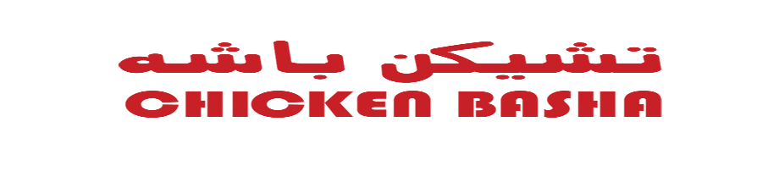

Date: _________

APPLICATION FOR AN CHICKEN BASHA FRANCHISE LICENSE

(SAUDI ARABIA)

I/We___________________________________________________________

Of _____________________________________________________________
Hereby submit an application to obtain CHICKEN BASHA Multi-unit franchising license:

In______________________________(the “City”), of __________________(the “REGION”). This application once submitted is subject to the following terms and conditions:

- Initial License Fee for this license is $40,000 payable in cash as outlined below:

- Five Thousand Dollars ($15,000) deposit (non-refundable, except as set forth in paragraph 2 below) payable to CHICKEN BASHA upon submitting this Application.

- $25,000 is due and payable to CHICKEN BASHA within seven (7) days of notification that my/our application has been approved. At such time, I/we will execute the CHICKEN BASHA License Agreement and appropriate Exhibits.

- I/we acknowledge that I/we have, at least ten business days, prior to the signing of this Application Agreement, received CHICKEN BASHA’s current form of License Offering Circular applicable to the appropriate Area. I/we understand that a completed form of the License Agreement will be provided at least five business days prior to signing the License Agreement, and that all other terms are to be in accordance with it.

- I/we have submitted a completed Confidential Qualification Report, including a completed Individual Financial Statement on CHICKEN BASHA’s form and I/we hereby authorize CHICKEN BASHA to conduct an investigation of my/our background to verify the information submitted.

- I/we acknowledge and understand that submission of this application does not bind or obligate CHICKEN BASHA to issue a License to me/us.

___________________________ ______________________________
(Signature) (Signature)

___________________________ ______________________________
Applicant (Print Name) Applicant (Print Name)

